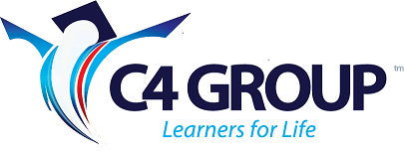

C4 Group – Certificate in Professional Investigations
The C4 Certificate in Professional Investigations covers the basic knowledge required to work in the professional investigations sector in New Zealand. It is aligned to the Australian Cert IV in Investigative Services and the UK Institute of Professional Investigators(IPI) Level III Professional Investigator’s course. This course will give you a platform from which you can start to build a career in investigations.
Course content.
Module 1:
- Professionalism within the industry
- Client relationships
- The NZ legal system
- Health and Safety
Module 2:
- Developing an investigative plan
- Gathering information by factual investigation
Module 3:
- Conducting interviews and taking statements
- Storage and protection of information
Module 4:
- Compiling an investigative report
- Preparing evidence for presentation in court
- Giving evidence in court
Module 5:
- Conducting surveillance
- Locating subjects

